Homework

Ex1:

#define _CRT_SECURE_NO_WARNINGS

#include <stdio.h>

int main() {

int num;

printf("Enter an integer you want to check:");

scanf("%d", &num);

printf("%d is ", num);

(num % 2 == 0) ? printf("even") : printf("odd");

return 0;

}

The output

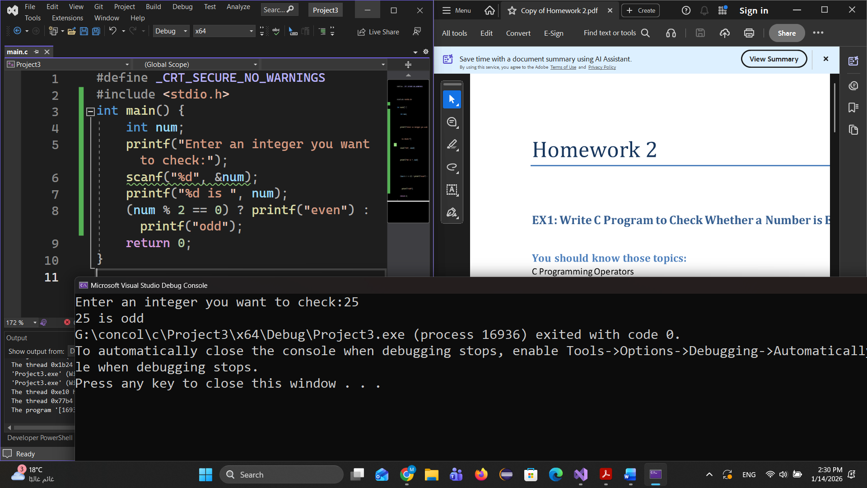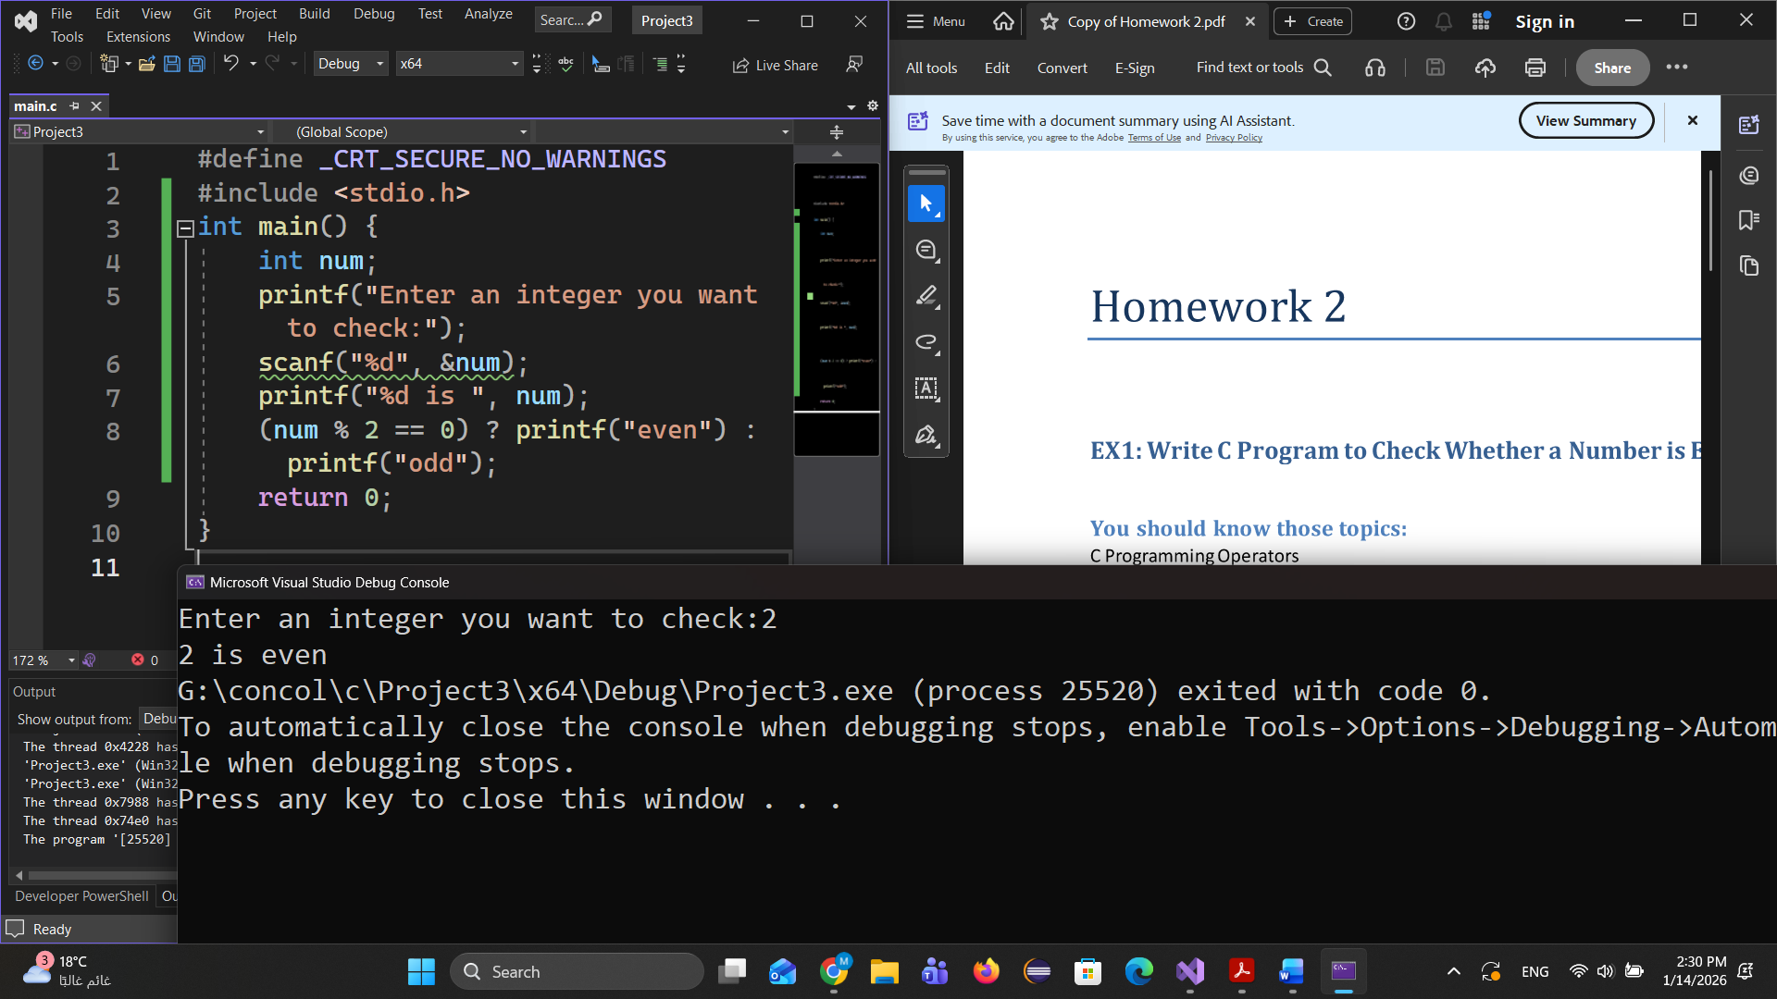

Ex2 :

#define _CRT_SECURE_NO_WARNINGS

#include <stdio.h>

int main() {

char ch;

printf("Enter an alphabet:");

scanf(" %c", &ch);

printf("%c is ", ch);

('a' == ch || 'e' == ch || 'i' == ch || 'o' == ch || 'u' == ch || ch == 'A' || ch == 'E' ||

ch == 'I' || ch == 'O' || ch == 'U') ? printf("vowel") : printf("consonant");

return 0;

}

Or

#define _CRT_SECURE_NO_WARNINGS

#include <stdio.h>

int main() {

char ch;

printf("Enter a character: ");

scanf(" %c", &ch);

switch (ch) {

case 'a': case 'e': case 'i': case 'o': case 'u':

case 'A': case 'E': case 'I': case 'O': case 'U':

printf("It is a vowel\n");

break;

default:

printf("It is not a vowel\n");

}

return 0;

}

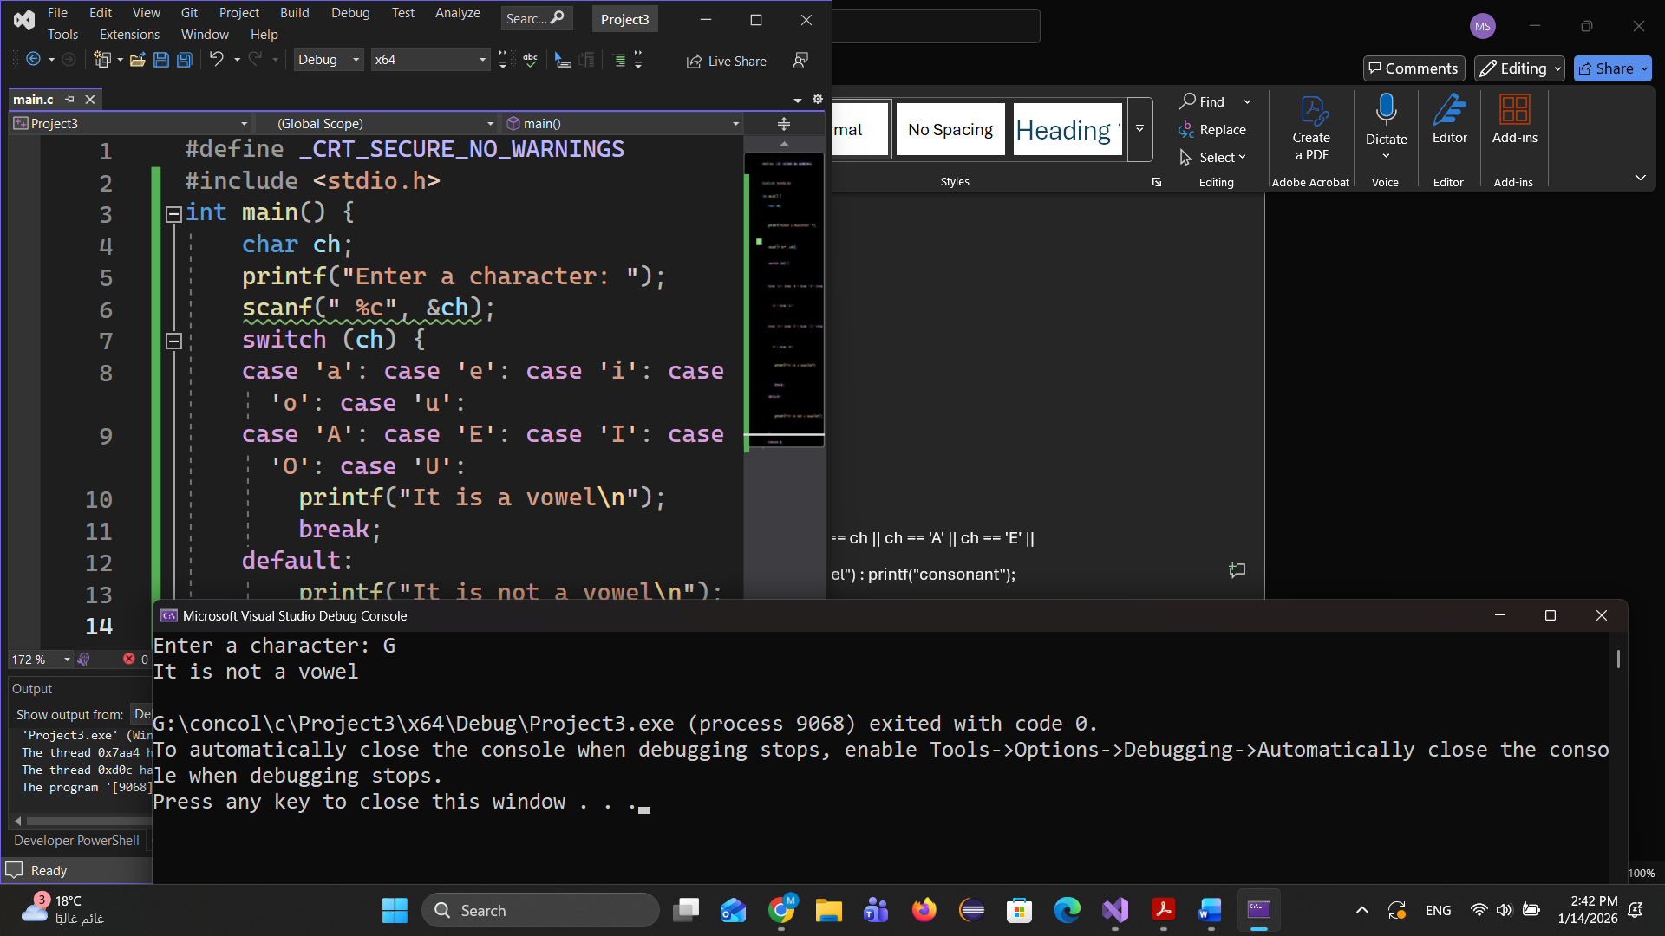The Output

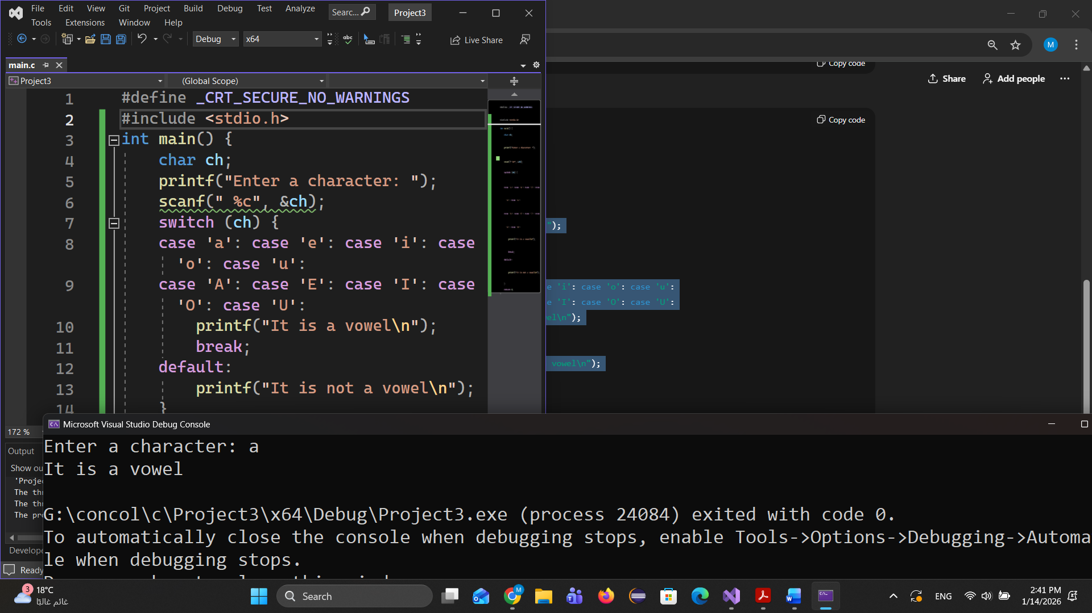

Ex3:

#define _CRT_SECURE_NO_WARNINGS

#include <stdio.h>

int main() {

float a, b, c, largest;

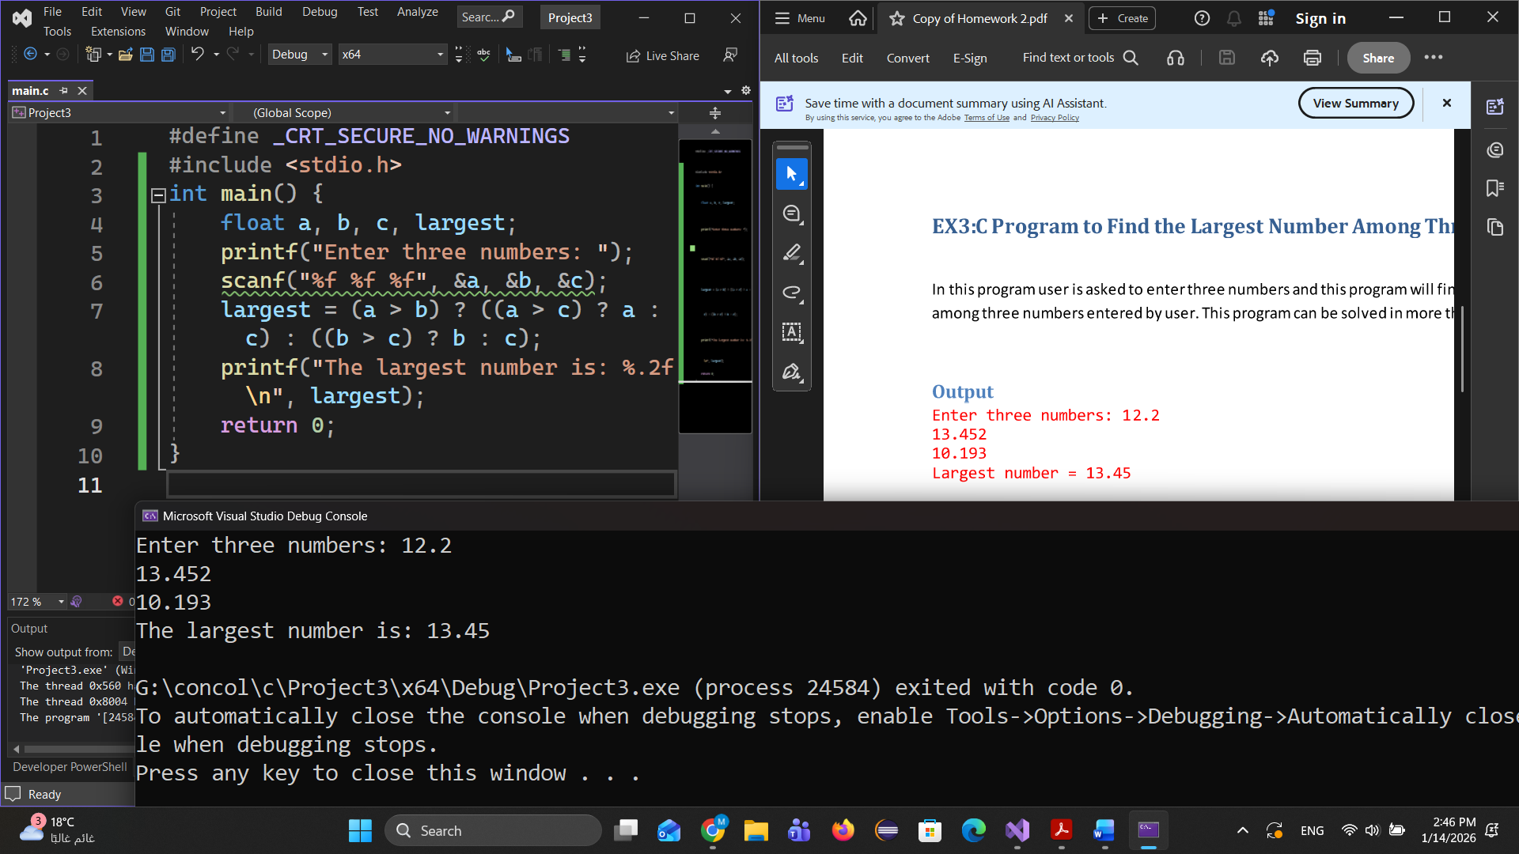 printf("Enter three numbers: ");

scanf("%f %f %f", &a, &b, &c);

largest = (a > b) ? ((a > c) ? a : c) : ((b > c) ? b : c);

printf("The largest number is: %.2f\n", largest);

return 0;

}

The output

Ex4:

#define _CRT_SECURE_NO_WARNINGS

#include <stdio.h>

int main() {

float a;

printf("Enter a number: ");

scanf("%f", &a);

(a > 0)?printf(" %.2f is Positive",a):(a==0)?printf("You entered zero"):printf(" %.2f is Negative",a);

return 0;

}

The output

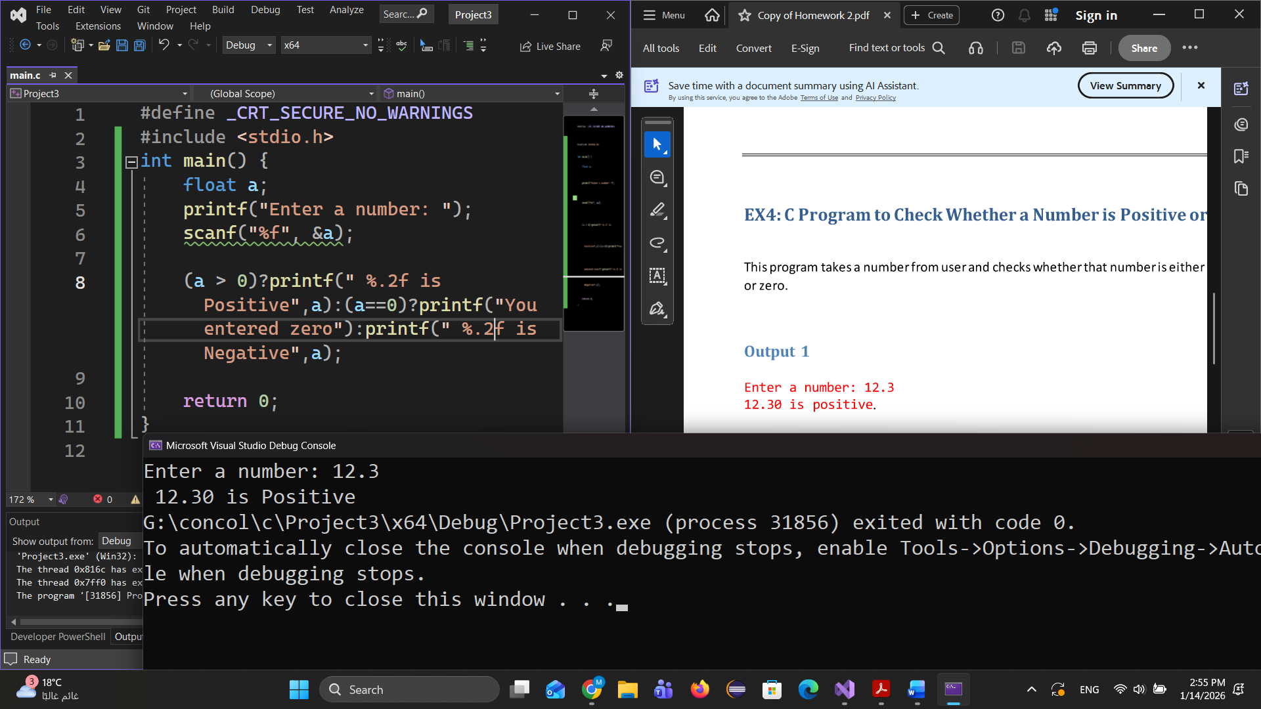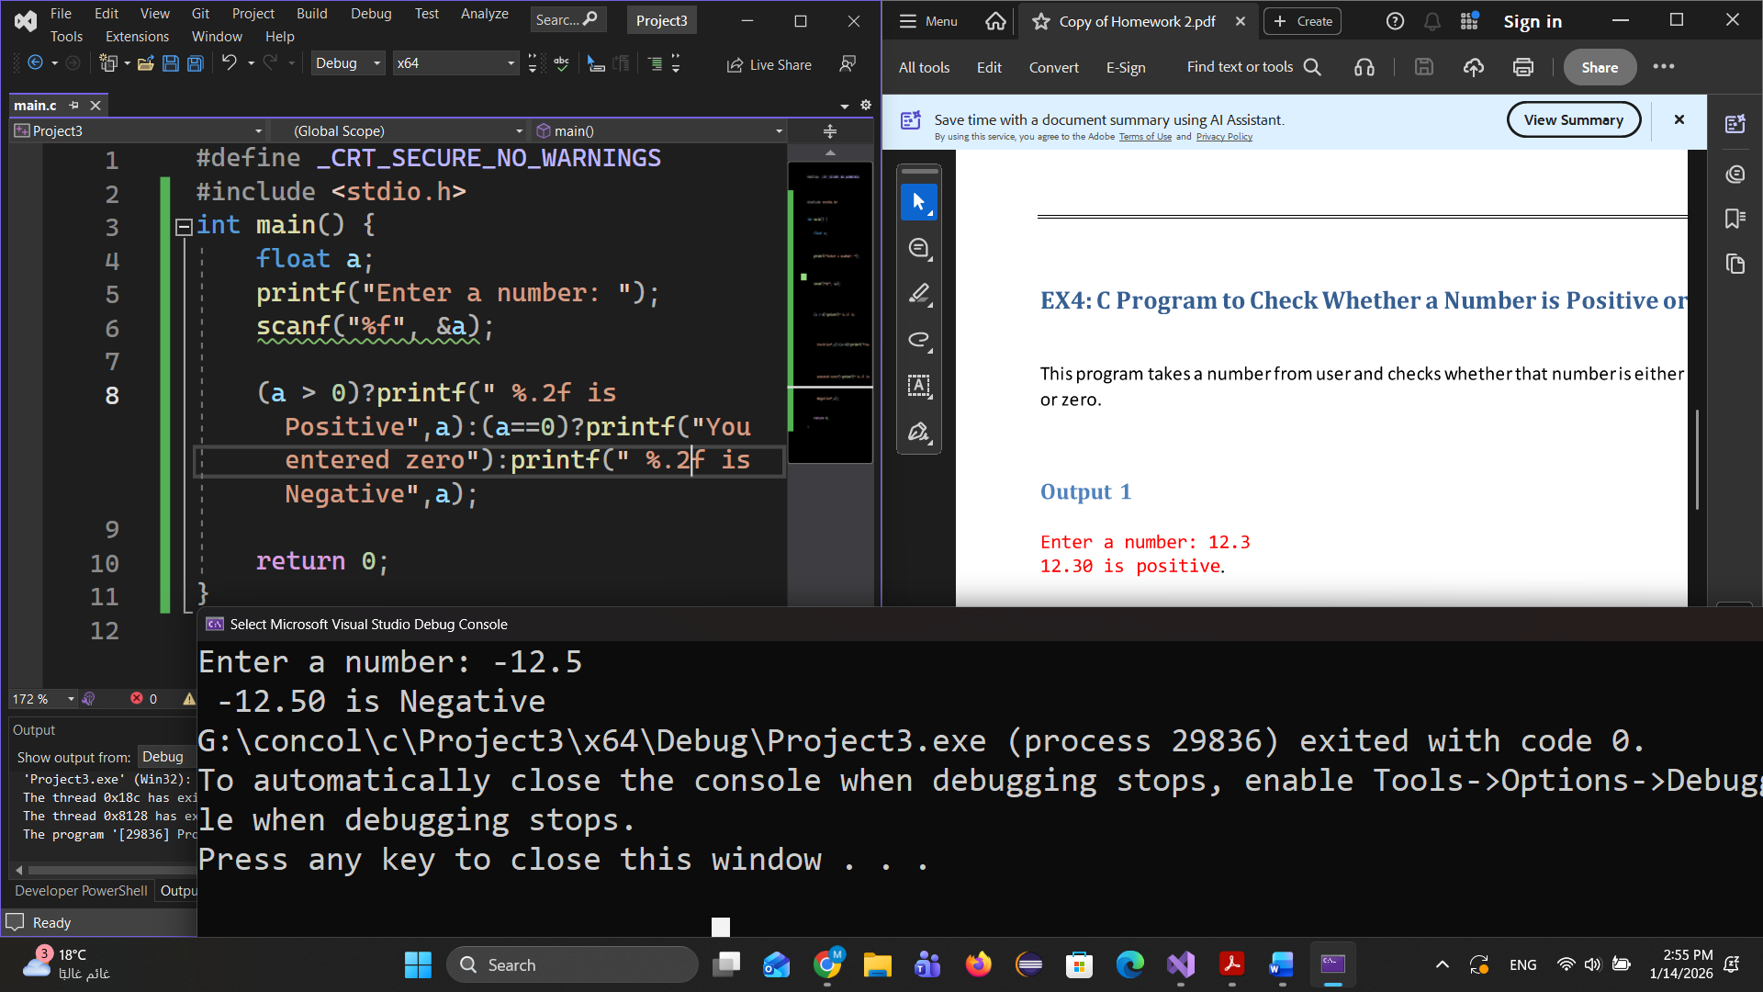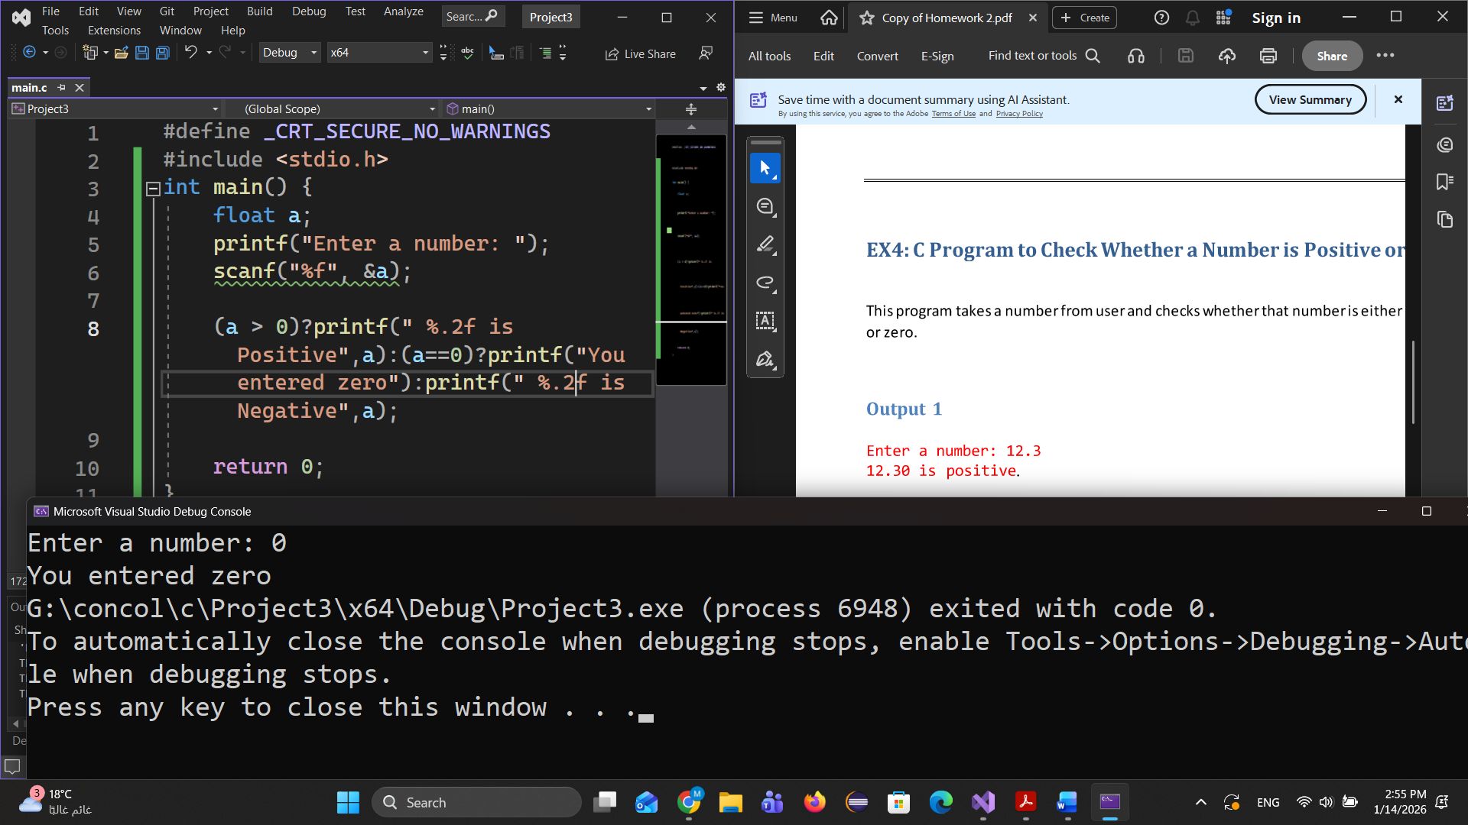

Ex5:

#define _CRT_SECURE_NO_WARNINGS

#include <stdio.h>

int main() {

char ch;

printf("Enter a character: ");

scanf(" %c", &ch);

if ((ch >= 'A' && ch <= 'Z') || (ch >= 'a' && ch <= 'z')) {

printf("%c is an alphabet\n", ch);

}

else

printf("%c is not an alphabet\n", ch);

return 0;

}

The Output

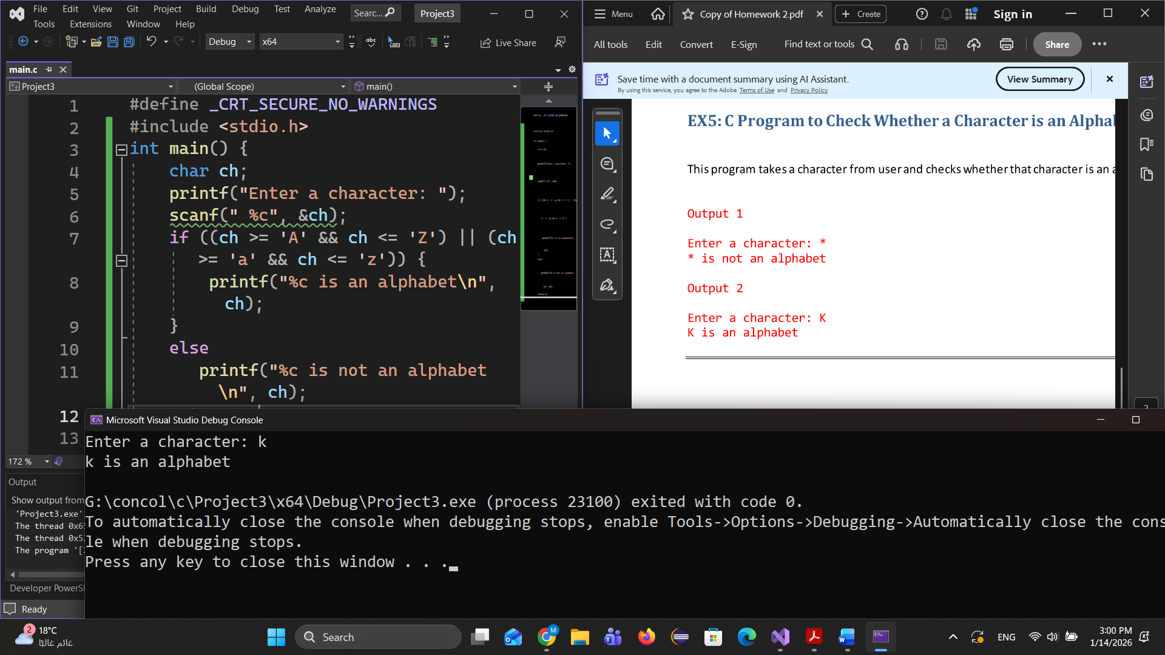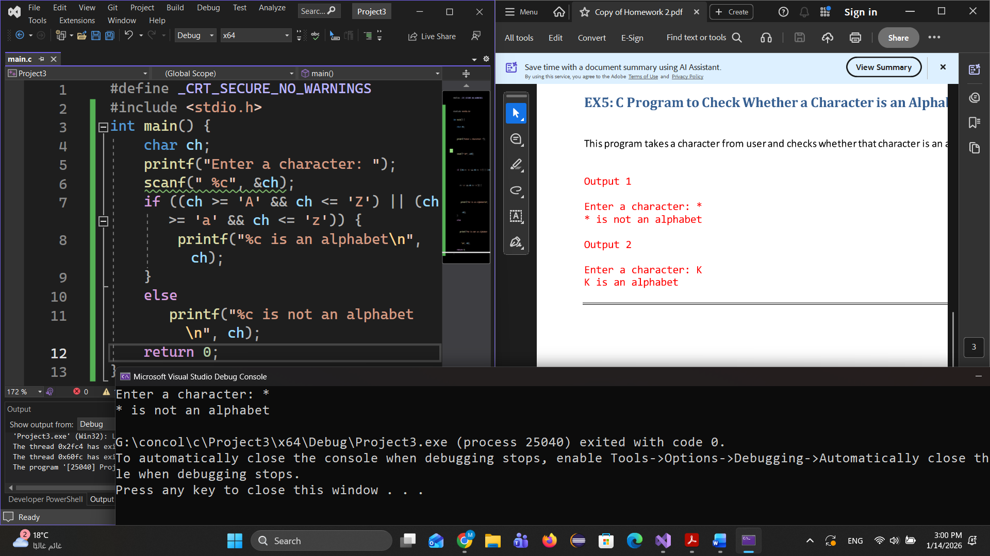

Ex6:

#define _CRT_SECURE_NO_WARNINGS

#include <stdio.h>

int main() {

int num;

printf("Enter an integer:");

scanf("%d", &num);

printf("Sum =%d", ((num * (num + 1)) / 2));

return 0;

}

The Output

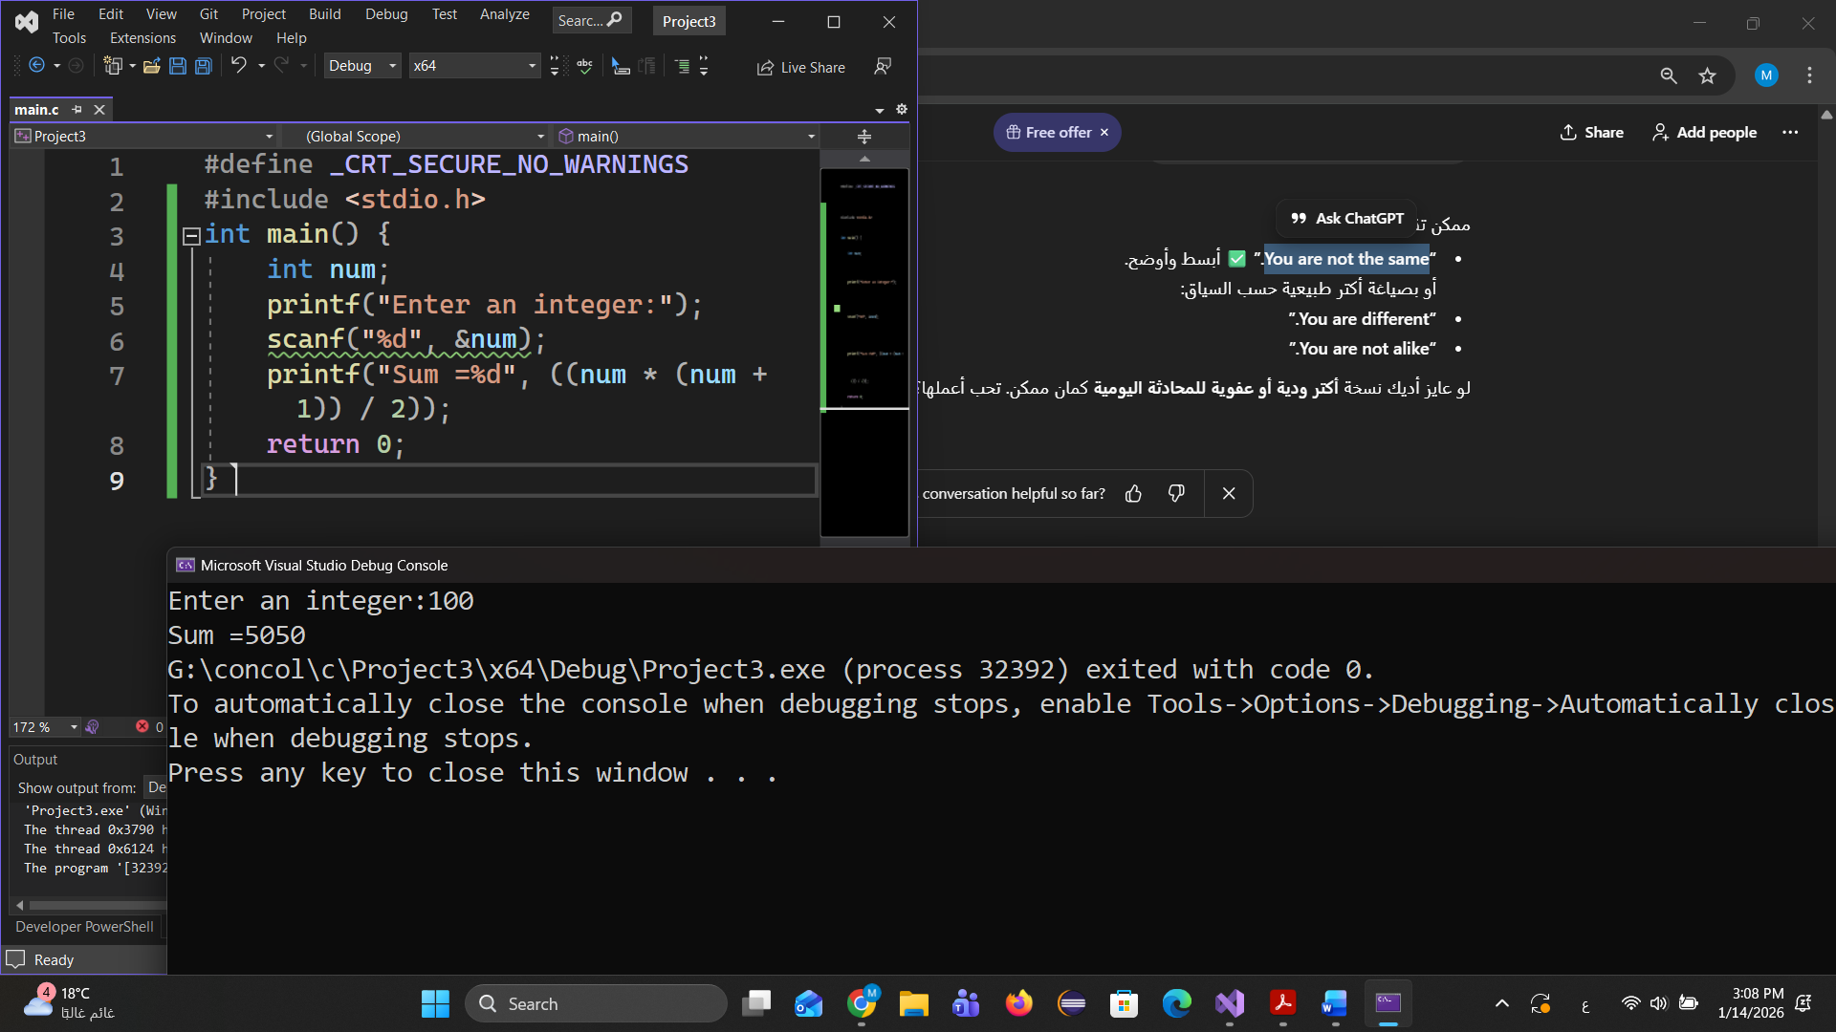

Ex7:

#define _CRT_SECURE_NO_WARNINGS

#include <stdio.h>

int main() {

int n, i;

unsigned long long factorial = 1;

printf("Enter a number: ");

scanf("%d", &n);

if (n < 0)

printf("Factorial of a negative number doesn't exist.\n");

else {

for (i = 1; i <= n; i++) factorial *= i;

printf("Factorial of %d = %llu\n", n, factorial);

}

return 0;

}

The Output

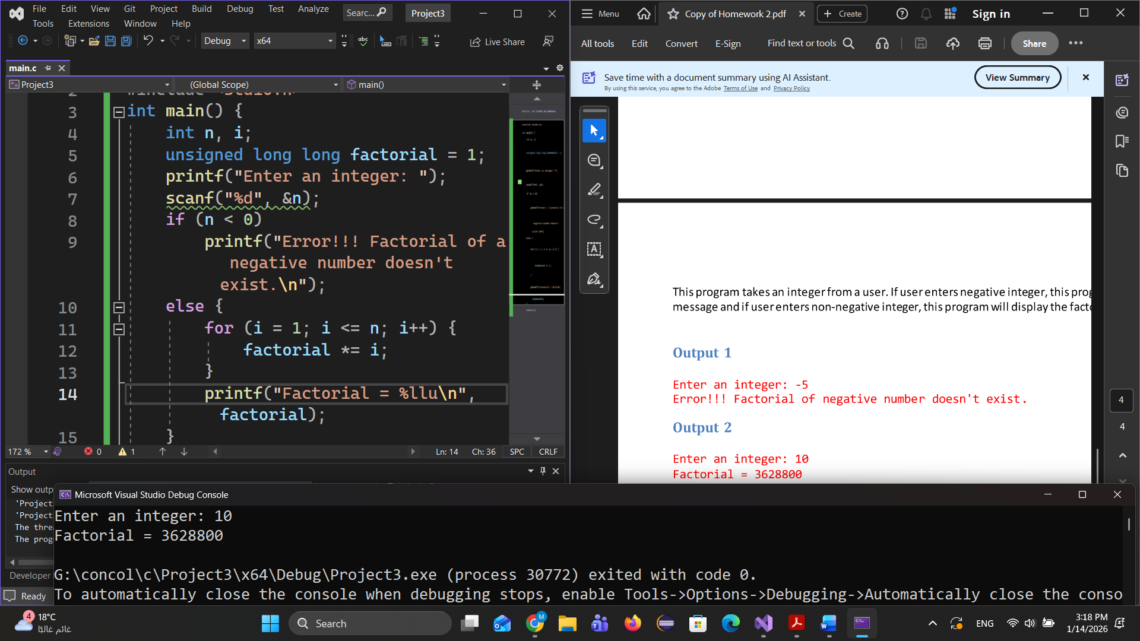

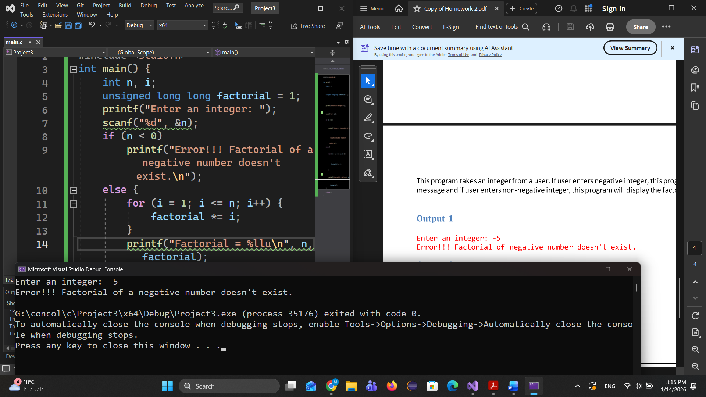

Ex8:

#define _CRT_SECURE_NO_WARNINGS

#include <stdio.h>

int main() {

float num1, num2,result;

char ch;

printf("Enter operator either + or - or * or divide : ");

scanf(" %c", &ch);

printf("Enter two operands: ");

scanf("%f %f", &num1,& num2);

('+' == ch) ? result = num1 + num2 : ('-' == ch) ? result = num1 - num2 :

('*' == ch) ? result = num1 * num2 : ('/' == ch) ? result = num1 / num2:printf("Error operator");

printf("%.2f %c %.2f= %.2f", num1, ch, num2, result);

return 0;

}

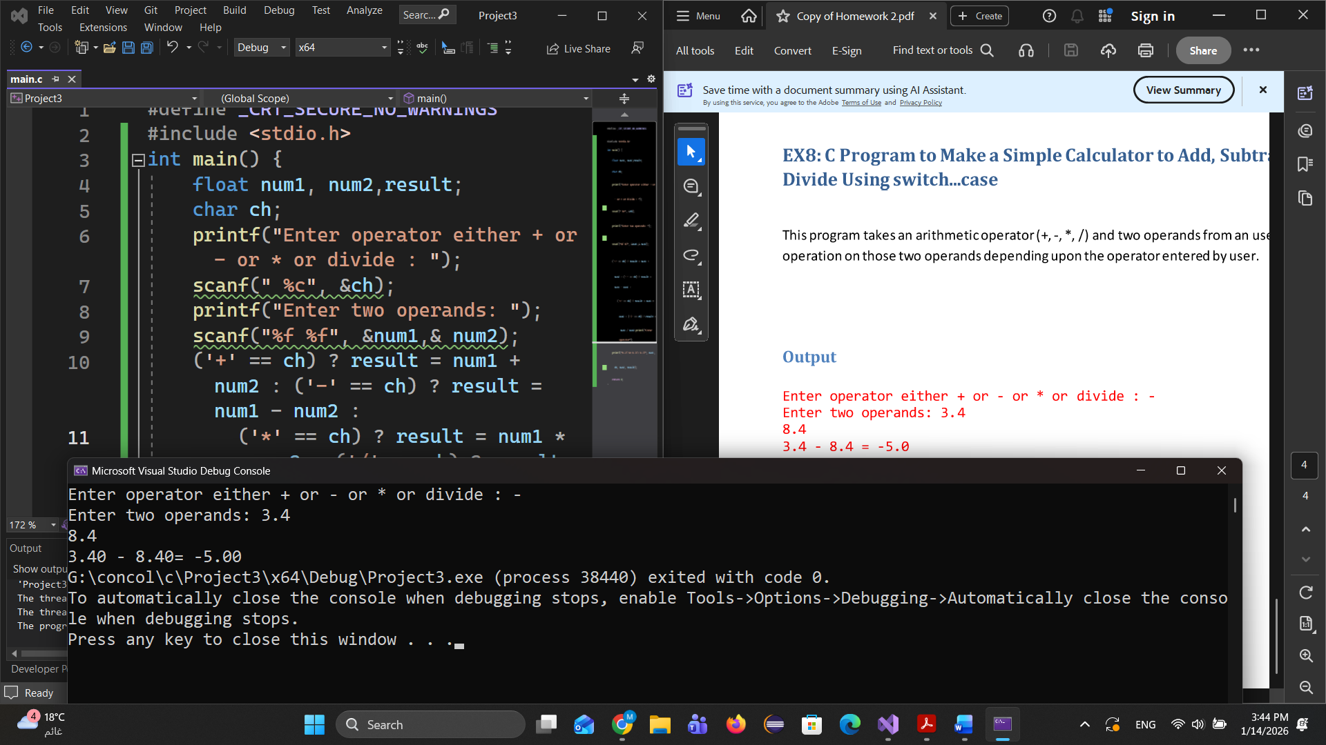The Output